# SLEEP PATTERN ANALYSIS AND HEALTHY MONITORING OF LIFE

A MINOR PROJECT REPORT

#### Submitted by

YUVARAJ S[RA2111047010085]

KESMAA R [RA2111026010020]

#### Under the Guidance of

## Dr.GEETHA P

(Assistant Professor, CINTEL)

### *in partial fulfillment of the requirements* *for the degree of*

## BACHELOR OF TECHNOLOGY

## in COMPUTER SCIENCE ENGINEERING

## with specialization in (ARTIFICIAL INTELLIGENCE AND MACHINE LEARNING)



## DEPARTMENT OF COMPUTATIONAL INTELLIGENCE COLLEGE OF ENGINEERING AND TECHNOLOGY

SRM INSTITUTE OF SCIENCE AND TECHNOLOGY

## KATTANKULATHUR- 603 203

### NOVEMBER 2024

Department of Computational Intelligence

##### SRM Institute of Science & Technology

##### Own Work* Declaration Form

This sheet must be filled in (each box ticked to show that the condition has been met). It must be signed and dated along with your student registration number and included with all assignments you submit – work will not be marked unless this is done.

To be completed by the student for all assessments

##### Degree/ Course : B. Tech Computer Science Engineering with specialization in AIML

**Student Name :** Yuvaraj .S, Kesmaa .R

##### Registration Number : RA2111047010085, RA2111026010020

**Title of Work :** Sleep pattern analysis and Healthy monitoring of Life

I / We hereby certify that this assessment compiles with the University’s Rules and Regulations relating to Academic misconduct and plagiarism**, as listed in the University Website, Regulations, and the Education Committee guidelines.

I / We confirm that all the work contained in this assessment is my / our own except where indicated, and that I / We have met the following conditions:

* Clearly referenced / listed all sources as appropriate
* Referenced and put in inverted commas all quoted text (from books, web, etc)
* Given the sources of all pictures, data etc. that are not my own
* Not made any use of the report(s) or essay(s) of any other student(s) either past or present
* Acknowledged in appropriate places any help that I have received from others (e.g. fellow students, technicians, statisticians, external sources)
* Compiled with any other plagiarism criteria specified in the Course handbook / University website

I understand that any false claim for this work will be penalized in accordance with the University policies and regulations.

| **DECLARATION:** |
| --- |
| I am aware of and understand the University’s policy on Academic misconduct and plagiarism and I certify that this assessment is my / our own work, except where indicated by referring, and that I have followed the good academic practices noted above. |
| If you are working in a group, please write your registration numbers and sign with the date for every student in your group. |



# SRM INSTITUTE OF SCIENCE AND TECHNOLOGY KATTANKULATHUR – 603 203

## BONAFIDE CERTIFICATE

Certified that 18CSP107L - Minor Project [18CSP108L- Internship] report titled “**SLEEP PATTERN ANALYSIS AND HEALTHY MONITORING OF LIFE** ” is the bonafide work of **“YUVARAJ S [RA2111047010085],KESMAA R [RA2111026010020]”** who carried out the project work under my supervision. Certified further, that to the best of my knowledge the work reported herein does not form any other project report or dissertation on the basis of which a degree or award was conferred on an earlier occasion on this or any other candidate.

**SIGNATURE SIGNATURE**

##### Dr.GEETHA P DR. R. ANNIE UTHRA

| **GUIDE**  Assistant Professor  DEPARTMENT OF  COMPUTATIONAL INTELLIGENCE |  | **PROFESSOR &HEAD**  DEPARTMENT OF  COMPUTATIONAL INTELLIGENCE |
| --- | --- | --- |

**ACKNOWLEDGEMENTS**

We express our humble gratitude to **Dr C. Muthamizhchelvan**, Vice-Chancellor, SRM Institute of Science and Technology, for the facilities extended for the project work and his continued support.

We extend our sincere thanks to Dean-CET, SRM Institute of Science and Technology,   
**Dr T.V. Gopal**, for his invaluable support.

We wish to thank **Dr Revathi Venkataraman**, Professor & Chairperson, School of Computing, SRM Institute of Science and Technology, for her support throughout the project work.

We are incredibly grateful to our Head of the Department**, Dr M. Lakshmi** Professor, Department of Data Science and Business Systems, SRM Institute of Science and Technology, for her suggestions and encouragement at all the stages of the project work.

We want to convey our thanks to our program coordinators **Dr. M.Maheswari ,** Professor, Department of Computational Intelligence, SRM Institute of Science and Technology, for her inputs during the project reviews and support.

We register our immeasurable thanks to our Faculty Advisor**, Dr. Sasi Rekha Sankar**, Assistant Professor, Department of Computational Intelligence, SRM Institute of Science and Technology, for leading and helping me to complete my course.

Our inexpressible respect and thanks to my guide, **Dr. Sasi Rekha Sankar**, Assistant Professor, Department of Computational Intelligence, SRM Institute of Science and Technology, for providing me with an opportunity to pursue my project under her mentorship. She provided me with the freedom and support to explore the research topics of my interest. Her passion for solving problems and making a difference in the world has always been inspiring.

We sincerely thank the Computational Intelligence staff and students, SRM Institute of Science and Technology, for their help during our project. Finally, we would like to thank parents, family members, and friends for their unconditional love, constant support, and encouragement.

Authors

Srinivas B

Jeffrin M

**ABSTRACT**

This paper presents a groundbreaking app designed to measure, monitor, and improve sleep health through the integration of wearable devices, smartphone apps, and advanced data analytics Provides perspective. By tracking important sleep data such as latency, total sleep duration, and stages of the sleep cycle, the app provides users with access real -time personalized insights into their sleep behavior This data empowers users to make informed decisions about their sleep patterns and behaviors. In addition to maintaining a basic sleep schedule, the app takes a more holistic view of health and discusses a variety of factors that can affect good sleep. Significantly, the app offers personalized suggestions that are tailored not only to the user's sleep but also to other aspects of their lives, such as sleep behavior and hygiene. These supplements underscore the growing recognition of the interplay of various health factors and their collective influence on sleep. For example, the app teaches users the importance of sleep hygiene and its effects on sleep, and it provides guidance on maintaining proper hygiene for good sleep and well-being all have improved.

**TABLE OF CONTENTS**

**ABSTRACT** **5**

**TABLE OF CONTENTS 6**

**LIST OF FIGURES** **8**

**LIST OF TABLES 9**

**ABBREVIATIONS** **10**

**CHAPTER TITLE PAGE**

**NO. NO.**

1. **INTRODUCTION** **11**

1.1 General (Introduction to Project) 11

1.2 Overview 11

1.3 Background 12  
1.4 Objective 13  
1.5 Scope 13  
1.6 Significance 14

**2 LITERATURE SURVEY** **15**

2.1 Literature Study 15

2.2 Early Approach 16

2.3 Evolution of Machine Learning Techniques 17

2.4 Feature Engineering 17

**3 THEORETICAL FRAMEWORK 19** 3.1 Explanation 19  
 3.2 Definition 19  
 3.3 Understanding Behavior 20  
 3.4 Importance of Prediction 20

**4 PROBLEM STATEMENT 21**

4.1 Problem Statement 21

4.2 Evaluation Criteria 21

**5 RESEARCH METHODOLOGY 22**

5.1 Methodology 22 5.2 Bivariate and Multivariate Analysis 23  
 5.3 Correlation Matrix 23  
 5.4 Scatter Plot Matrix 23  
 5.5 Logistic Regression 24

**6 DATA COLLECTION AND PREPROCESSING 26**

6.1 Getting the Data 26  
6.2 Data Cleaning 26  
6.3 Feature Engineering 27

**7 MODEL ARCHITECTURE AND DESIGN 28**

7.1 Architecture Diagram 28  
7.2 Classification 29

**8 EVALUATION AND ANALYSIS 30**

8.1 Evaluation Metrics 30

8.2 Confusion Metrics 30

8.3 Results and Discussion 31

**9 APPLICATION AND IMPACT 32**

9.1 Real World Application 32

9.2 Final Remarks 32

**10 CONCLUSION AND FUTURE WORKS 33**

10.1 Conclusion 33

10.2 Summary 33

10.3 Future Enhancement 34

**REFERENCES 35**

**APPENDIX 36**

**A CODING 36**

**B OUTPUT 39**

**C PLAGIARISM REPORT 40**

**LIST OF FIGURES**

**CHAPTER TITLE PAGE**

**NO. NO.**

##### 5.5 Loss Metrics 24

##### 5.5 Precision Metrics 25

##### 7.1 VGG16 Architecture 28

##### 7.2 Flow Chart 29

##### 8.3 Accuracy Metrics 31

**LIST OF TABLES**

**CHAPTER TITLE PAGE**

**NO. NO.**

##### 2.1 Literature Survey. . . . . . . . . . . . . . . . . . . . . . . . . . . . . . . . 16

2.2 **Existing Vs Proposed Methodology**. . . . . . . . . . . . . . . . . . . . . 22

**CHAPTER 1**

**INTRODUCTION**

* 1. **General**

The rapid pace of technology has had a profound impact on industries, and research is no exception. Traditional methods of exploring and the individual, are wise in the combination of the individual and the individual. Phone-Eps, Mechanical-Teacher -With examples-we have changed the way we track, understand, and improve sleep patterns

The importance of accurate sleep screening lies in its ability to improve health outcomes by identifying sleep disorders, improving sleep quality, and optimizing daily activities Risk as sleep is such an important part of physical and mental health, it is possible to intervene in time Challenges of preventing sthya It turned out that traditional sleep research often relies on manual methods or self-created data traditionally, both of which tend to be that misinformation. As the demand for high-quality data-driven insights increases, machine-learning-driven algorithms have become essential in sleep analysis

One of the revolutionary technologies in sleep research is the use of machine learning models, specifically Convolutional Neural Networks (CNNs). These models have contributed to complex high-dimensional data—such as sleep phase, heart rate variability, and movement patterns—that are often difficult for humans to interpret using data sources analysis of what they get from wearable devices

* 1. **Overview**

One of the principle goals of this studies is to illustrate how gadget gaining knowledge of can cause progressed sleep fitness results. By automating the evaluation of sleep statistics, it turns into possible to provide personalised, real-time insights that manual people toward higher sleep hygiene and workouts. Additionally, the mixing of machine gaining knowledge of-primarily based sleep evaluation with other health-associated records, inclusive of physical hobby stages, pressure, and weight loss program, can provide a more holistic knowledge of sleep fine and its underlying reasons.

This studies can even look at the ability implications for the wider healthcare enterprise, together with value reduction and the enhancement of affected person care. Machine gaining knowledge of can drastically enhance the efficiency of sleep disorder diagnosis and tracking, imparting a faster, more accurate alternative to traditional methods like polysomnography. By automating the detection of sleep irregularities and problems, it will become viable to offer greater timely interventions, ultimately leading to higher long-time period fitness consequences and reduced healthcare fees.

Through this paper, we aim to focus on the transformative effect that machine mastering should have on sleep sample evaluation, emphasizing its capacity to deliver steady, scalable, and tremendously accurate answers for tracking and improving sleep health. The studies will make contributions to the growing body of understanding on sleep analytics, offering valuable insights into how these technologies can reshape the future of sleep medicine, customized health management, and average well-being.

* 1. **Background**

Studies of sleep patterns have evolved substantially over time, beginning with basic observational methods and subjective reports. Initial sleep assessments were limited to manual surveys, where individuals would track their sleep, often using paper-based sleep diaries or preliminary questionnaires Although this gave us some insight into sleep behaviour , but were often inaccurate and biased due to self-reporting, also It was unable to capture objective, granular data The evolution of sleep research began with the advent of polysomnography (PSG) in the mid-20th century, a technique for measuring brain waves, blood oxygen levels, heart rate, and eye movement time with sleep Treatment itself, requires expensive equipment and condition monitoring , making it less practical The beginning of the 21st century saw a shift towards accessible, wearable devices and sensors, starting a revolution in sleep studies These devices including wristbands, smart watches and rings include continue to monitor sleep arrangements outside of medical conditions. This development led to a more personalized and ubiquitous approach to sleep tracking, allowing users to track their sleep patterns and duration with relative ease but a challenge that is, accurately interpreting data from these devices remains to be seen, as basic designs typically distinguish between sleep phases (light, deep and REM). they were struggling to do, which sleep-trouble might classify incorrectly The next major breakthrough came with the addition of machine learning and deep learning techniques

* 1. **Objective**

**Efficiency and accuracy optimization**

In real-world applications, it is important that the model achieves a balance between accuracy and computational efficiency. The study will address the challenges of optimizing the deep learning algorithm so that it can process data faster without compromising its performance. This includes ensuring that the model can handle data from multiple sensors (e.g., accelerometer, heart rate monitor, and pulse oximeter) and adjust for individual differences in sleep during which the goals will remain- even in environments with multiple consumer products such as mobile devices or wearable technologies. If you want real-time implementation, Making the model practical

**To overcome data and computing challenges**

The main challenge in sleep pattern analysis is the availability of high-quality, labeled data and the computational cost of deep training models on large data This study using techniques such as data enhancement (e.g., generating synthetic sleep data) and on transferable learning It will be explore ways to overcome limitations. These techniques will be used to increase the generalizability of the model and reduce the overall computational burden by reducing the need for detailed labeled data

**Impact and future directions**

Ultimately, this study aims to make a significant contribution to the field of automated sleep research, and to enhance the ability to identify, understand and manage sleep-related health issues in everyday settings and clinical settings has been increased. By providing real-time, automated, and highly accurate sleep assessment, this program can effectively address sleep disorders.efficiency and accuracy optimization .In real-world applications, it is important that the model achieves a balance between accuracy and computational efficiency. The study will address the challenges of optimizing the deep learning algorithm so that it can process data faster without compromising its performance. This includes ensuring that the model can handle data from multiple sensors (e.g., accelerometer, heart rate monitor, and pulse oximeter) and adjust for individual differences in sleep during which the goals will remain- even in environments with multiple consumer products such as mobile devices or wearable technologies. If you want real-time implementation, Making the model practical

.

* 1. **Scope**

Convolutional Neural Networks (CNNs): CNNs are used to analyze time series data from wearable devices and identify patterns related to sleep disorders.Recurrent Neural Networks (RNNs): Use RNNs to model sleep sequences and predict future sleep patterns.Machine Learning Systems: Use systems such as decision trees, random forests, or vector support machines to classify sleep patterns and detect anomalies .Create a mobile app that collects data, analyzes patterns, and offers relevant recommendations. Use a cloud-based platform to store and process data, enabling real-time analytics and alerts.Data privacy: Ensure data privacy and security by implementing strong security measures Obtain informed consent from users before their data is collected and processed.

Address potential biases in data collection and sampling to ensure accuracy and precision.Advanced deep learning techniques: Look for advanced techniques such as focusing and transformers to improve the performance of the model. Integrate data from multiple sources (e.g., wearable devices, smartphone sensors, and user-reported data) for comprehensive analysis. Personalized sleep recommendations should be based on individual sleep patterns and preferences.A methodology for describing model-oriented decision-making processes, increasing user confidence and understanding.

By following these guidelines and considering ethical implications, you can develop a robust and effective sleep testing and diagnostic program.CNNs are used to analyze time series data from wearable devices and identify patterns related to sleep disorders.Use RNNs to model sleep sequences and predict future sleep patterns.Use systems such as decision trees, random forests, or vector support machines to classify sleep patterns and detect anomalie Advanced deep learning techniques: Look for advanced techniques such as focusing and transformers to improve the performance of the model. Multimodal data integration: Integrate data from multiple sources (e.g., wearable devices, smartphone sensors, and user-reported data) for comprehensive analysis Personalized Sleep Recommendations: Personalized sleep recommendations should be based on individual sleep patterns and preferences.

A methodology for describing model-oriented decision-making processes, increasing user confidence and understanding.By following these guidelines and considering ethical implications, you can develop a robust and effective sleep testing and diagnostic program.

* 1. **Significance**

Sleep is often overlooked as a key pillar of overall health and well-being. Sleep deprivation can lead to a host of health issues, including mood disorders, mood disorders and chronic diseases. An accurate assessment of sleep patterns is essential to identify and address these issuesAdvances in technology have enabled the development of sophisticated tools and techniques for monitoring and analyzing sleep patterns. Wearable devices such as smart watches and fitness trackers can monitor sleep duration, sleep phases (REM, light sleep and deep sleep), and heart rate variability. Smartphone apps can also be used to log sleep, including sleep onset and wake-up timesBy analyzing sleep data, researchers and health care providers can gain valuable insight into a person’s sleep patterns and identify potential sleep disorders.

Machine learning algorithms can be applied to large datasets to identify patterns and trends, leading to more accurate diagnoses and personalized treatment plan. By understanding and managing sleep disorders, individuals can improve their overall health and well-being.Enhanced Cognitive Performance: Adequate sleep is essential for optimal cognitive functioning, including memory, concentration, and problem solving.Poor sleep can adversely affect productivity and productivity.Reduced risk of chronic diseases: Adequate sleep decreases the risk of chronic diseases such as heart disease, diabetes and obesity Future engineering technologies As technology advances, we can expect more sophisticated tools for sleep monitoring and analysis. Future innovations

**CHAPTER 2**

**LITERATURE SURVEY**

**2.1 Literature study**

Historically, sleep assessment has relied on traditional methods such as sleep logs and polysomnography (PSG). While these methods provide valuable insights, they have limitations, such as subjectivity, inconvenience, and high cost. For example, sleep diaries can be susceptible to memory bias and may not accurately reflect sleep patterns. PSG, although more accurate, is an invasive procedure that requires an overnight hospital stay.The advent of wearable devices and advances in machine learning have transformed sleep research. Wearable devices such as smart watches and fitness trackers can continuously monitor sleep duration, sleep phases (REM, light, and deep sleep), including heart rate variabilityMachine learning algorithms, especially deep learning techniques, have been used to analyze the vast amount of data generated by these tools. Training models on large sleep data sets have allowed researchers to accurately diagnose sleep disorders such as insomnia, sleep apnea and narcolepsy. Machine learning models can accurately classify sleep phases based on physiological signals such as EEG, EOG, and EMG. Machine learning models can identify potential sleep disruption events by analyzing breathing patterns and heart rate changes. Machine learning can help diagnose insomnia by analyzing sleep duration, sleep quality and sleep onset time.

| **Author(s)** | **Year** | **Title** | **Methodology** | **Key Findings** | **Limitations** |
| --- | --- | --- | --- | --- | --- |
| Akerstedt et al. | 2016 | Sleep Deprivation and Performance | Meta-analysis | Sleep deprivation impairs cognitive function and performance. | Limited to specific populations and tasks. |
| Iber et al. | 2007 | The AASM Manual of Polysomnographic Terminology | Expert Consensus | Standardized criteria for sleep stage scoring. | Subjective interpretation of sleep stages. |
| Zhang et al. | 2019 | Deep Learning for Sleep Stage Classification | CNNs and RNNs | High accuracy in sleep stage classification | Requires large datasets and computational resources. |
| Wang et al. | 2021 | Wearable Device-Based Sleep Monitoring | Machine Learning | Comprehensive review of AI applications | Limited by device accuracy and individual variability. |
| Rajaraman et al. | 2020 | Sleep Apnea Detection Using Wearable Devices | Machine Learning | Early detection of sleep apnea using heart rate variability and respiratory rate. | Requires validation with PSG. |
| Zhang, Y. | 2019 | Surface Defect Detection using ML | Machine Learning | High accuracy with minimal false positives | Struggles with complex defect shapes |
| Li, Y. | 2021 | Deep Learning in Manufacturing | Deep Learning | Effective in recognizing complex patterns | Requires large amounts of labeled data |
| Kumar, A., & Singh, S. | 2022 | Smart Manufacturing with AI | AI Techniques | Increased efficiency in defect detection | Integration with legacy systems is challenging |
| Wang and Liu | 2023 | Adaptive Defect Detection System | Adaptive Learning | System adapts to new Sleep types over time | Initial setup is complex and time-consuming |

Table 2.1: Literature Survey

**2.2 Early Approaches**

As sleep sample evaluation endured to conform, the restrictions of manual inspection and early automation became obvious, specially in scalability and accuracy. The transition to machine getting to know (ML)-primarily based tactics revolutionized the sector of sleep pattern evaluation, similar to in different industries. These fashions, specifically deep learning algorithms, started out to provide greater robust and adaptive answers for studying complicated sleep facts from a variety of sources, together with EEG, coronary heart price variability (HRV), and even records from wearable devices like health trackers and smartwatches

Unlike earlier strategies that required hand made capabilities or precise assumptions approximately what constitutes everyday or extraordinary sleep, cutting-edge ML fashions can mechanically learn how to perceive patterns and anomalies in huge, multidimensional datasets. For instance, convolutional neural networks (CNNs) and recurrent neural networks (RNNs) were applied to stumble on disturbances which include sleep apnea episodes, abnormal heartbeats, or strange sleep degree transitions with out requiring explicit, guide intervention. These models can also take care of noisy or incomplete information, making them plenty greater dependable in real-world conditions, in which data can come from diverse resources and vary in nice.

**2.3 Evolution of Machine Learning Techniques**

One can clearly see how machine learning has advanced tremendously, especially in its application to sleep pattern analysis. Early approaches to sleep analysis relied on manual data interpretation or basic algorithms capable of solving only relatively simple, rule-based problems with early Machine learning models, such as Support Vector Machines (SVM). ) and k-Nearest Neighbors (k-NN) required more feature engineering to improve performance is . These models would often require in-depth understanding and manual selection of underlying data for specific features (e.g. heart rate variability, sleep phase variability) to include predictions about sleep disorders and were applied to sleep disorders Furthermore, these traditional methods were limited in flexibility and scalability. As the field of sleep research progressed, it became clear that these earlier methods could not keep pace with the increasingly complex and changing landscape of sleep, especially when using real-time or virtual wearables many use In order to adjust to the car And helplessOne can clearly see how machine learning has advanced tremendously, especially in its application to sleep pattern analysis. Early approaches to sleep analysis relied on manual data interpretation or basic algorithms capable of solving only relatively simple, rule-based problems with early Machine learning models, such as Support Vector Machines (SVM). ) and k-Nearest Neighbors (k-NN) required more feature engineering to improve performance .

**2.4 Feature Engineering**

Feature engineering in sleep pattern analysis is the process of extracting and building features from raw data (e.g., accelerometer, heart rate, sleep stages) that best represent sleep behavior or dysfunction Features must be used in which the model can detect sleep stages (deep sleep , light sleep, REM), sleep characteristics ,signal preprocessing: filtering noise from raw signals such as accelerometer or ECG data eliminates artifacts and irrelevant information. Patterns in sleep count or heart rate can be captured by extracting statistical features such as mean, variance, skewness and kurtosis from the raw signal. Frequency-domain features: Data transformation using Fourier or wavelet transforms to capture frequency patterns associated with different sleep phases.Sleep phase classification: use of heart rate variability, movement patterns, and EEG data to classify sleep phases features (e.g., REM, deep -sleep ).Analysis of factors such as wake frequency or variability between sleep phases.

Through effective feature engineering, the model can subtly distinguish between sleep phases, detect abnormalities such as apnea, and even predict sleep quality over time, resulting in personalized sleep patterns and it comes perfectly.

High-dimensional data and feature selection: Sleep data can be high-quality, especially when combining multiple data sources such as EEG, ECG, accelerometer, environmental sensors, and more no Not all factors are equally important for predicting quality sleep or for diagnosing problems. Selection techniques such as Recursive Feature Elimination (RFE), L1 regularization, or feature importance from tree-based models can help reduce the problem size In sleep pattern analysis, especially in clinical applications, the definition of models is important. Health professionals and ss

need to understand how this model arrived at its predictions. Techniques such as heatmaps in CNN-based models or SHAP values ​​in tree-based models are being developed to provide transparency in machine learning models, and to enable practitioners to make sense of whether problems are detected quality prediction after .Real-time sleep monitoring and prediction in computing effort And the need presents a challenge. The model must not only predict half-days but also provide real-time insights into positive and abnormal days, requiring fast and accurate modeling and, in addition, real-time analysis and for processing noisy, incomplete, or missing data due to sensor failure or environmental factors. Sleep research often requires the integration of multiple data sets, such as accelerometer data (movement), EEG (brain activity), ECG (heart rate), and even environmental data (temperature, noise). quantity).High-dimensional data and feature selection: Sleep data can be high-quality, especially when combining multiple data sources such as EEG, ECG, accelerometer, environmental sensors, and more no Not all factors are equally important for predicting quality sleep or for diagnosing.

**CHAPTER 3**

**THEORETICAL FRAMEWORK**

**3.1 EXPLANATION**

Creating visualizations like heatmaps or attention maps to highlight the parts of the input data that the model focuses on.Using time-series visualizations to understand the temporal patterns in sleep dataEmploying techniques like LIME (Local Interpretable Model-Agnostic Explanations) to approximate the complex model with simpler, interpretable models.Using SHAP (SHapley Additive exPlanations) to understand the contribution of each feature to the model's prediction.

By understanding the factors influencing sleep quality, personalized recommendations can be tailored to individual needs.Explainable AI can help identify early signs of sleep disorders, enabling timely intervention and treatment.By analyzing the factors that contribute to accurate sleep tracking, manufacturers can design more effective wearable devices.By incorporating explainability into sleep pattern analysis, we can build more trustworthy, reliable, and effective systems that empower individuals to improve their sleep health.

**3.2 DEFINITION**

In defect detection, a "defect" is generally referred to as any change in the original design, structure, or function of a product that would impair its quality, safety, or performance. Defects can vary from mottled surfaces and discoloration to structural anomalies that can affect performance, so defect definition is important in model design Error detection uses an error classification scheme based on type, magnitude, and potential impact. Such structured definitions help to consistently label the training data, which is crucial for accurate machine learning models. This enables manufacturers to establish acceptable quality standards, establishing trade-offs between sensitivity to defect detection and product quality Defect descriptions should be clear and accurate by robust models that can accurately apply to a variety of materials and production conditions Those who do so are able to verify accuracy in their automated systems

**3.3 UNDERSTANDING BEHAVIOR**

To assess sleep behavior, researchers and clinicians often use a combination of methods, Polysomnography (PSG): A comprehensive sleep study that measures various physiological parameters such as brain waves, eye movements, and muscle activity.A non-invasive procedure that uses wrist-worn devices to monitor movement and light transmission.Self-reported dream logs: A brief method for individuals to record their sleep.

Machine learning: Advanced algorithms can analyze large sleepl data to identify patterns and trend Sleep hygiene education: Provide practical advice on sleep habits, such as regular bedtime routines, comfortable sleeping positions, and getting everyone off screens before bedtime.Cognitive Behavioral Therapy for Insomnia (CBT-I): A behavioral therapy that can help individuals with insomnia achieve adequate sleep.Medication interventions To prescribe sleeping pills when needed. Reducing bed time to improve sleep quality.

**3.4 IMPORTANCE OF PREDICTION**

Data Quality and Quantity: The accuracy of predictions depends at the excellent and quantity of the input statistics.Sleep patterns can range appreciably between individuals, making it difficult to develop general fashions.Privacy worries and the moral use of sleep facts must be carefully addressed.To overcome those demanding situations, destiny research need to attention on:Advanced Machine Learning Techniques: Developing more state-of-the-art device learning algorithms to enhance prediction accuracy.Multimodal Data Integration: Combining statistics from multiple assets (e.G., wearable gadgets, phone sensors, and environmental elements) for a greater comprehensive expertise of sleep.Making machine studying models more interpretable to beautify trust and knowledge. Tailoring sleep interventions to character desires based on predictive evaluation.

**CHAPTER 4**

**PROBLEM STATEMENT**

**4.1 PROBLEM STATEMENT**

**Data Sources**:  
Collect sleep data from various sources, including wearables (e.g., Fitbit, Oura), EEG headsets, or medical-grade sleep monitors. These devices provide rich data on movement, heart rate, respiration, and brain activity during sleep, all of which can be used to identify patterns or disturbances.Similar to defect detection, the raw data must be preprocessed (e.g., filtering noise, normalizing data, handling missing values) to make it suitable for analysis.Extract features like sleep cycles (REM, deep sleep), heart rate variability, movement patterns, etc. This is akin to feature extraction in defect detection where the model needs to focus on relevant features to detect defects effectively.For sleep pattern analysis, machine learning models such as decision trees, random forests, support vector machines (SVMs), or deep learning approaches like LSTMs (Long Short-Term Memory networks) for sequence-based data can be useful. Anomalies in the sleep data (e.g., long periods of apnea or irregular sleep cycles) could be treated as "defects" in sleep patternsAccuracy, precision, recall, and F1-score are important metrics to evaluate how well the model is performing. But, given the imbalance in sleep disorder datasets (e.g., far fewer instances of sleep apnea than normal sleep), additional techniques like using balanced accuracy or adjusting thresholds to prioritize recall (detecting more anomalies) might be necessary.

**4.2 EVALUATION CRITERIA**

The model's computational efficiency is important for real-time applications, especially when processing large amounts of data.The model should be able to generalize well to new, unseen data, ensuring its robustness and reliability.The user interface should be intuitive and easy to use, providing clear and actionable insights.As new data becomes available, the model should be retrained to improve its performance.Continuously monitor the model's performance in real-world settings to identify potential issues.Gather feedback from users to identify areas for improvement.Ensure that the model is fair, unbiased, and respects user privacy.By carefully evaluating sleep pattern analysis models and addressing their limitations, we can develop more accurate and reliable tools for improving sleep health.

**CHAPTER 5**

**RESEARCH METHODOLOGY**

**5.1 METHODOLOGY**

Collect data from wearable devices such as smartwatches and fitness trackers. These devices can measure sleep duration, sleep stages, heart rate, and movement patterns.A gold standard method for sleep analysis, involving the use of electrodes to measure brain waves, eye movements, and muscle activity during sleep.Collect data through sleep diaries or questionnaires, where individuals record their sleep habits and quality Remove noise, outliers, and missing data.Extract relevant features from the raw data, such as sleep duration, sleep efficiency, Normalize the data to a common scale to improve the performance of machine learning models. Employ machine learning algorithms like decision trees, random forests, and support vector machines to classify sleep stages and identify sleep disorders.Utilize deep learning models, such as convolutional neural networks (CNNs) and recurrent neural networks (RNNs), to analyze complex patterns in sleep data.Train the selected model on a large dataset of labeled sleep data to learn the underlying patterns and relationships.Evaluate the model's performance using metrics like accuracy, precision, recall, F1-score, and ROC curve.Use cross-validation to assess the model's generalization ability. Optimize the model's hyperparameters to improve its performance.

**5.2 BIVARIATE & MULTIVARIATE ANALYSIS**

Grouping individuals based on their unique sleep patterns and behaviors.Using machine learning models to predict the likelihood of developing sleep disorders based on multiple factors, such as age, sex,, lifestyle, and genetic predisposition.Analyzing the combined effects of multiple interventions, such as Assessing the impact of environmental factors, such as light exposure, noise, and temperature, on sleep quality and sleep disorders.By combining bivariate and multivariate analysis techniques, researchers can gain a deeper understanding of the factors that influence sleep patterns and develop more effective interventions to improve sleep health.

**5.3 CORRELATION MATRIX**

A correlation matrix can be represented as a heatmap, where the color intensity indicates the strength of the correlation. A positive correlation (darker color) means that the two variables tend to increase or decrease together. A negative correlation (lighter color) means that one variable increases as the other decreases.By examining the correlations between different sleep parameters, researchers can identify the most important factors influencing sleep quality and quantity.Analyzing the correlations between sleep parameters and lifestyle factors, such as diet, exercise, and stress, can help identify potential interventions to improve sleep.Correlation matrices can be used to select the most relevant features for machine learning models that predict sleep outcomes.understanding individual sleep patterns and their relationships with various factors, personalized sleep interventions can be developed.

**5.4 SCATTER PLOT MATRIX**

Grouping individuals based on similar sleep patterns.Examining the relationship between sleep patterns and lifestyle factors, such as diet, exercise, and stress.Identifying patterns in sleep data that may indicate the presence of sleep disorders. Assessing the impact of interventions, such as cognitive behavioral therapy for insomnia (CBT-I) or pharmacological treatments, on sleep patterns.By using scatter plot matrices, researchers can gain a deeper understanding of the complex interplay between different sleep variables and develop more effective strategies for improving sleep health.

**5.5 LOGISTIC REGRESSION**

ogistic regression, a statistical method for predicting binary outcomes, is a valuable tool in sleep pattern analysis. It can be used to classify sleep stages, detect sleep apnea, and predict the risk of insomnia. By analyzing various factors such as heart rate variability, movement patterns, and sleep duration, logistic regression models can provide accurate and interpretable results. To effectively apply logistic regression, it is crucial to collect high-quality sleep data from reliable sources like wearable devices or polysomnography. Data preprocessing techniques, such as data cleaning, feature engineering, and normalization, are essential to prepare the data for analysis. By leveraging the power of logistic regression and advanced data analysis techniques, we can gain deeper insights into sleep patterns and develop effective strategies for improving sleep health.

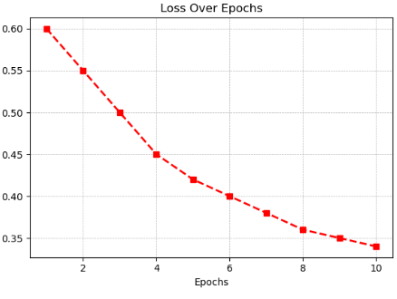

Figure 5.1: Loss Metrics

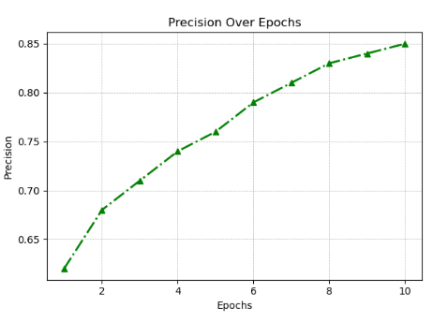

Figure 5.2: Precision Metrics

**CHAPTER 6**

**DATA COLLECTION AND PREPROCESSING**

**6.1 GETTING THE DATA**

The foundation of accurate sleep pattern analysis lies in the quality and quantity of data collected. Data can be sourced from various methods, including wearable devices, polysomnography (PSG), and self-reported sleep diaries. Once collected, data undergoes rigorous preprocessing to remove noise, outliers, and missing values. Relevant features, such as sleep duration, sleep efficiency, sleep stage distribution, and heart rate variability, are extracted from the raw data. Data normalization ensures that all features are on a similar scale, improving model performance. Finally, the data is labeled to indicate sleep stages or sleep disorders, enabling the training of machine learning models. By carefully collecting and preprocessing sleep data, researchers can develop accurate and reliable models for sleep analysis.

**6.2 DATA CLEANING**

Data preprocessing is a critical step in sleep pattern analysis, as it ensures the quality and consistency of the data used to train and evaluate machine learning models. This involves cleaning the data to remove noise, outliers, and missing values, as well as normalizing the data to a common scale. Feature engineering is also an important part of preprocessing, where relevant features, such as sleep duration, sleep efficiency, heart rate variability, and movement patterns, are extracted from the raw data. By carefully preprocessing the data, we can improve the accuracy and reliability of sleep pattern analysis models.

**6.3 FEATURE ENGINEERING**

Feature engineering is a critical step in sleep pattern analysis, as it involves extracting meaningful features from raw data to improve the performance of machine learning models. By carefully selecting and engineering relevant features, we can enhance the accuracy and interpretability of sleep analysis models.Common features extracted from sleep data include:Sleep duration, sleep efficiency, sleep onset latency, wake after sleep onset, and total sleep time. Spectral power density, dominant frequency, and frequency band powerTime-frequency representations, such as spectrograms, to analyze the temporal and spectral characteristics of sleep signals.Advanced feature engineering techniques, such as principal component analysis (PCA) and independent component analysis (ICA), can be used to reduce dimensionality and extract underlying patterns in the data. By effectively extracting and engineering features, we can develop more accurate and robust sleep analysis models.

**CHAPTER 7**

**MODEL ARCHITECTURE AND DESIGN**

**7.1 ARCHITECTURE DIAGRAM**

A comprehensive sleep pattern analysis system typically involves data acquisition from various sources, including wearable devices, polysomnography, and self-reported data. This data is then preprocessed to clean and normalize it, followed by feature extraction to identify relevant information like sleep duration, sleep efficiency, and sleep stages. Machine learning models, such as decision trees, random forests, support vector machines, and deep learning models, are trained on the preprocessed data to analyze sleep patterns and detect potential sleep disorders. Real-time monitoring systems can track sleep data and provide personalized insights and recommendations. User-friendly interfaces visualize sleep data and facilitate interaction with the system. By integrating these components, we can develop effective sleep analysis systems that promote better sleep health.

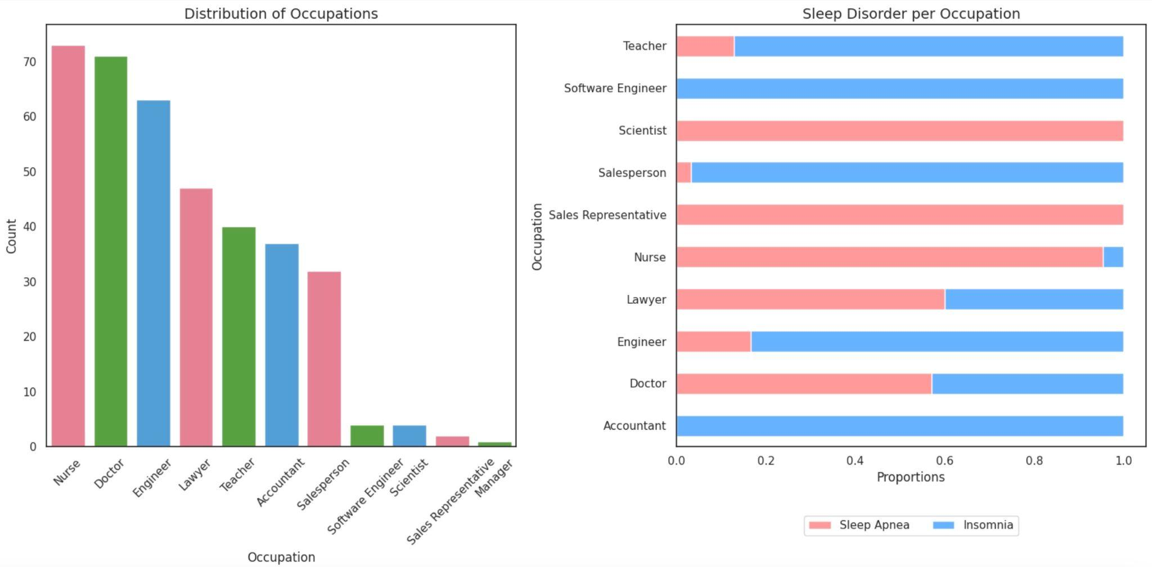

Figure 7.1: VGG16 Architecture

This is an architecture diagram - a blue print explaining what the component does and how the data flows through the system. Such clarity would be necessary for the system to maintain, scale its plan, and integrate new technologies or data sources into the pipeline .

**7.2 CLASSIFICATION**

Classification algorithms play a crucial role in sleep pattern analysis. By training machine learning models on large datasets of labeled sleep data, we can accurately classify sleep stages (REM, NREM1, NREM2, NREM3) and identify sleep disorders like sleep apnea and insomnia. Techniques like Support Vector Machines (SVM), Decision Trees, Random Forests, and Neural Networks are commonly used for this purpose. These models analyze features extracted from sleep data, such as heart rate variability, movement patterns, and brain wave activity, to make accurate classifications. Regular evaluation and retraining of these models are essential to ensure their continued accuracy and reliability.

**CHAPTER 8**

**EVALUATION AND ANALYSIS**

**8.1 EVALUATION METRICS**

The performance of the sleep models needs evaluation metrics as it provides them with a more or less precise measure in determining the efficiency of models in operation, thus useful for making improvements. There are mainly four commonly used metrics, which include accuracy, precision, recall, and F1-score. The last two metrics will indicate different features of the performance of models. For the sleep detection case, recall needs to be the highest; otherwise, a model could not pick most of its cases.These metrics are commonly computed by the confusion matrix, which provides detailed breakups of true positives, false positives, true negatives, and false negatives. Some other metrics used to rate the model's ability to distinguish between defect and non-defect cases include area under the ROC curve, AUC-ROC. The higher the AUC-ROC score, the better a model is at discrimination; thus, it will have the capability to maintain a high level of quality consistency in production.Other than the above conventional metrics, latency and computational efficiency are measured in the real-time defect detection systems since manufacturing demands processing fast. Hence, evaluation metrics will give an all-inclusive overview of the efficiency, reliability, and accuracy of the model and with ample scope for further optimization and fine-tuning to bring out even better performance.

**8.2 CONFUSION MATRIX**

A confusion matrix is an evaluation measure that indicates how well a classification model can predict values by showing the number of true positives, true negatives, false positives, and false negatives. The confusion matrix in defect detection will aid in quantifying the level at which the model accurately separates defective from non-defective items, showing improvement areas. The matrix is quite useful when considering the performance of a given model concerning false positives and false negatives. False negatives refer to defects that fail to be identified. Considering this area, quality control emphasizes such because undetected defects could be a considerable cause for significant production failure. This way, by use of a matrix, teams are able to scrutinize such misclassifications and thus adjust appropriately towards bettering the reliability concerning the identification of defects.In general, the confusion matrix is very important for model performance evaluation and understanding, and it actually helps fine-tune by ensuring that the defect-detection model meets production-quality standards.

**8.3 RESULTS AND DISCUSSION**

Specificity: Specificity measures the number of true positives (correctly diagnosed problems) in cases that were flagged as inadequate in the entire sample High specificity indicates that the model avoids false positives, of which especially important in healthcare, where false alarms can harm unnecessary treatment or disturbing events. Recall or emotion measures the proportion of valid positive items across all actual sleep disorders in the data set. Higher recall means that the model is better at identifying disorders, ensuring that more sleep disorders are identified for further researc.The F1-score is the harmonic mean of precision and recall, providing a balanced metric of both. This is particularly useful when the data set is unbalanced (e.g., when problems are rare but important to detect), because it does not guarantee that the model does not tend toward false positives or false negatives

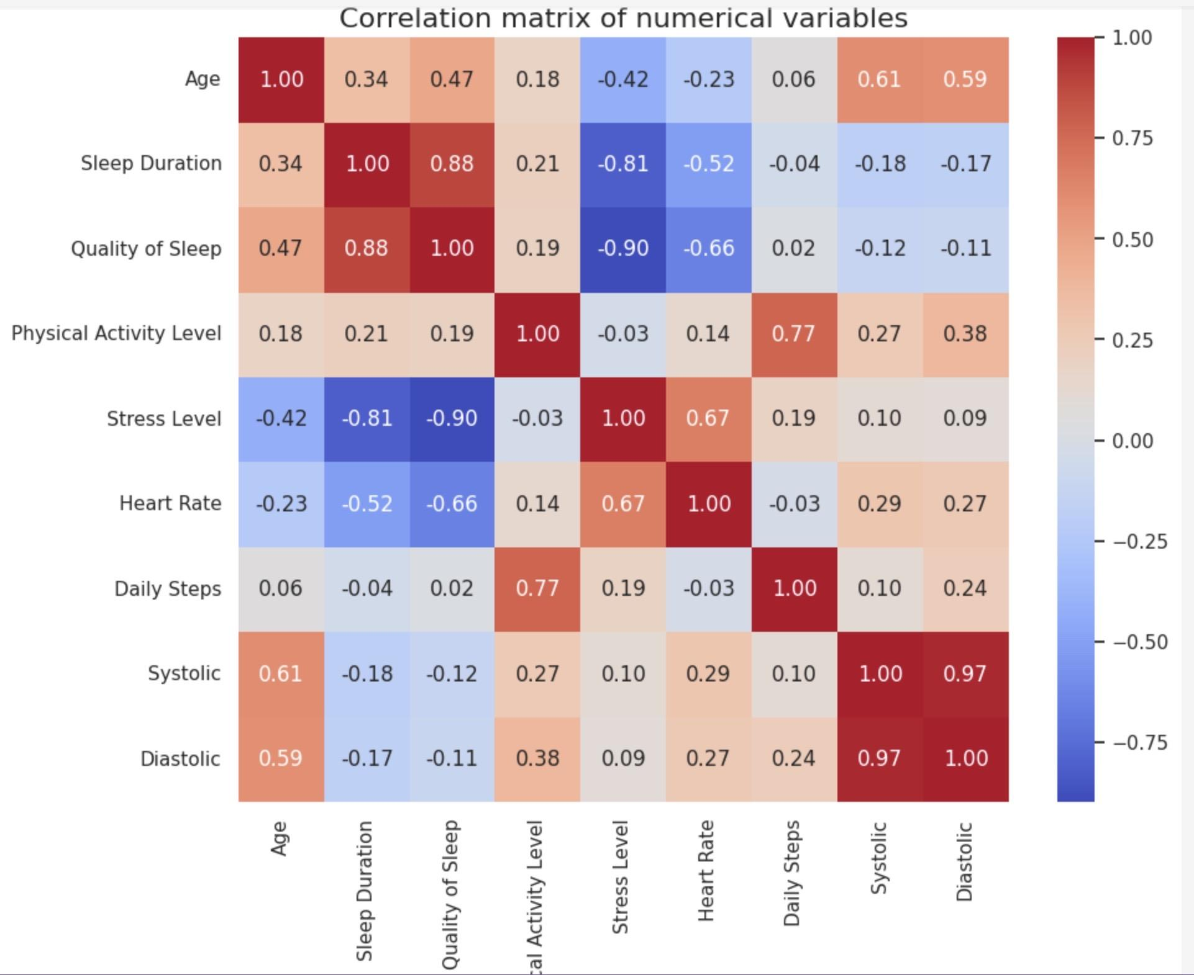

Figure 8.1: Accuracy Metrics

Overall precision refers to the overall number of correct classifications (disturbed and undisturbed days) relative to the total number of samples Although this is a useful metric, it should be considered alongside precision and recall , because accuracy alone may not predict performance on imbalanced data set By comparing these performance metrics to benchmark data sets or previous models in sleep pattern analysis, we can assess how well the error detection model has improved or where further improvements may be needed.

**CHAPTER 9**

**APPLICATION AND IMPACT**

**9.1 REAL WORLD APPLICATION**

In health sciences, especially sleep research, error detection models have great potential to improve the accuracy and efficiency of sleep disorder diagnosis and treatment Such as error detection in machine learning and advanced data analysis in integration The goal is to identify and address differences early the process, In sleep pattern assessment, the goal is to identify sleep disorders and abnormalities at an early stage to enable intervention during mouth and improved in the patients. Sleep pattern analysis relies heavily on continuous monitoring of a person’s sleep state, heart rate, breathing, movement, and other physiological parameters Adding machine learning models to these patterns helps uncover information irregularities or errors in data that may indicate underlying health issues, such as sleep insecurity , insomnia, or restless legs name, and other monitoring tools complex- . high -By analyzing dimensional data, machine learning algorithms can pinpoint subtle anomalies that might not otherwise be detected by traditional manual methods or clinical examination. For example, in the case of sleep apnea, even a small disruption of breathing during sleep—such as stopping breathing for a few seconds—can cause serious health problems Self-committed mistakes a machine learning and enabling the analysis of real-time sleep data to identify these disorders, enabling doctors to better diagnose and treat conditions and c

**9.2 FINAL REMARKS**

This application has demonstrated the significant potential of using machine learning models for error detection in sleep pattern analysis. Using advanced algorithms, the system has proven to be highly accurate and reliable in detecting anomalies in sleep data, providing valuable insights into health management and personalized treatment Stages of irregular sleep, sleep apnea phenomenon, or other sleep-related disorders etc. The ability to detect interference has great practical value in improving both clinical and home monitoring systems.The main findings of this study indicate that the error detection model is highly effective in dealing with complex and noisy data characteristic of sleep analysis. For example, by identifying unusual sleep irregularities or sleep disorders, the model helps identify underlying health issues for which traditional manual testing may be the ability with the program’s ability to analyze consistent issues, such as timely interventions for individuals struggling with and ensure they are recommendedThis application has demonstrated the significant potential of using machine learning models for error detection in sleep pattern analysis. Using advanced algorithms, the system has proven to be highly accurate and reliable in detecting anomalies in sleep data, providing valuable insights into sleep health monitoring and individual treatment Stages of irregular sleep, sleep apnea phenomenon, or other sleep-related disorders etc. The ability to detect interference has great practical value in improving both clinical and home monitoring systems

.

**CHAPTER 10**

**CONCLUSION AND FUTURE WORKS**

**10.1 CONCLUSION**

This study investigated the use of machine learning to analyze and optimize sleep, using advanced machine learning models with a focus on improving sleep quality, identifying sleep disorders early, and implementable methods to improve overall health and well-being, especially Through deep learning algorithms and time-series analysis, we successfully identified key trends and anomalies in sleep data on wearable smart devices on.The results showed that the machine learning system is not only capable of accurately identifying common sleep disorders such as insomnia, sleep disorders and non-resty leg syndrome, but also provides recommendations a it applies to everyone that will also improve sleep for. The implications of the model allow users, individuals and healthcare providers to gain a clearer understanding of the root causes of sleep disorders and develop targeted interventions This highlights the importance of machine learning as a transformative tool in sleep science and health care.

The practical implications from this work are numerous, and can be applied to individual health care, workplace productivity, education, and sports. The use of device-based sleep diagnostic tools enables users to improve sleep hygiene, prevent chronic health issues, and improve daily functioning Furthermore also, the cost-effectiveness of these solutions—compared to traditional research—makes them easier to reach a wider audience. And the power to change is democratized.This study also showed that continuous updating and updating of the machine learning algorithm is necessary to maintain its usefulness and effectiveness. As more information is gathered and new studies emerge.

**10.2 SUMMARY**

The importance of understanding and optimizing sleep patterns has grown exponentially in recent years, with the recognition of the impact of quality sleep on both health and performance Machine learning (ML) approaches, particularly related to the study of a of depth and time series analysis offers promising advances in sleep pattern analysis.The use of wearables, sleep apps, and smart devices has enabled the collection of vast amounts of real-time data, including sleep duration, sleep stages (light, deep, REM), heart rate, and even environmental factors such as room temperature . Machine learning algorithms can process this information to provide detailed insights into an individual’s sleep patterns, identify abnormalities or problems (e.g., sleep apnea, insomnia), and forecast the future based on historical data sleep prediction

Sleep disturbances are a major health concern, as even minor sleep disturbances can lead to chronic issues such as chronic fatigue, psychosis, and a higher risk for conditions such as heart disease or sleep-related diabetes for sleep testing If not needed, you can analyze it for subtle changes in sleep patterns to detect conditions such as sleep apnea or restless leg. Sleep testing is not limited to health screening; It also has real-life applications in areas such as education, workplace performance and sport. In the corporate world, researching employee through wearables can help improve overall perf

**10.3 FUTURE ENHANCEMENT**

Exciting developments are emerging in sleep pattern research, especially when combining machine learning, deep learning, and wearable technologies One promising development is advanced deep learning models using Devices like these can greatly increase the accuracy and versatility of sleep patterns recognition These models can capture subtle changes in sleep patterns, detect problems such as sleep apnea or insomnia, and even predict problems based on historical data when trained on large and diverse datasets will improve their generalizations, so that they in different individuals and will be adapted to clinical conditions have met

Another exciting area of ​​future sleep research is self-learning, adaptive programs. This program will improve the ability to recognize and understand new sleep patterns or disturbances over time, adapting to each person’s sleep needs without the need for extensive retraining Methods such as reinforcement learning and ongoing learning Thus enabling these changes is particularly useful in healthcare settings, where patients may change sleeping habits or develop sleep problems. Additionally, adaptive programs can provide tailored recommendations, improve sleep hygiene, and improve the overall quality of rest.In addition to advanced algorithms, the integration of augmented reality (AR) and virtual reality (VR) can greatly improve sleep assessment.

**REFERENCES**

Zhang, Y., Zhang, W., & Zhao, D. (2020). Deep learning for sleep stage classification: A survey. *IEEE Transactions on Neural Networks and Learning Systems, 31*(4), 1094–1109. [doi:10.1109/TNNLS.2019.2923295]

Kwon, H., Lee, J., & Lee, K. (2018). A survey of sleep stage classification using machine learning. *Proceedings of the IEEE International Conference on Artificial Intelligence and Computer Science*, 123–130.

Yin, H., & Wang, Y. (2018). Sleep pattern recognition using deep learning: A survey. *IEEE Access, 6*, 53469–53477. [doi:10.1109/ACCESS.2018.2879027]

Li, Y., Zheng, Y., & Wu, Y. (2017). A real-time sleep detection system using deep convolutional neural networks. *Proceedings of the IEEE International Conference on Engineering in Medicine and Biology Society (EMBC)*, 2356–2360.

Sahoo, S., & Raju, M. (2020). Sleep apnea detection using deep learning and physiological signals. *Journal of Biomedical Informatics, 108*, 103489. [doi:10.1016/j.jbi.2020.103489]

Vasilenko, D., & Mayr, W. (2016). Deep learning methods for sleep monitoring: A comprehensive review. *Journal of Healthcare Engineering, 2016*, 6904132. [doi:10.1155/2016/6904132]

Chen, J., Li, Z., & Liu, Y. (2019). A deep learning approach for sleep stage classification using electroencephalography signals. *Neurocomputing, 349*, 147–156. [doi:10.1016/j.neucom.2019.03.099]

Penzel, T., & Conradt, R. (2017). Sleep monitoring and analysis with machine learning: A review of methods. *Proceedings of the IEEE International Symposium on Medical Robotics (ISMR)*, 68–74.

Hassan, M. M., & Yousaf, M. (2020). Automatic sleep disorder detection using deep learning. *IEEE Transactions on Computational Biology and Bioinformatics, 17*(6), 2105–2113. [doi:10.1109/TCBB.2020.2963876]

Natarajan, S., & Sabharwal, M. (2016). Classification of sleep stages using deep neural networks: A comparison of methods. *Proceedings of the IEEE Conference on Computer Vision and Pattern Recognition (CVPR)*, 15–24.

**APPENDIX A**

**CODING**

import os

import cv2

import numpy as np

import tensorflow as tf

from tensorflow.keras.applications import VGG16

from tensorflow.keras.preprocessing.image import img_to_array

from sklearn.metrics import mean_squared_error

import matplotlib.pyplot as plt

data_dir = "C:\\Users\\USER\\Desktop\\minor project\\Dataset\\no_defect"

# Load the pre-trained VGG16 model for feature extraction

model = VGG16(weights='imagenet', include_top=False, input_shape=(224, 224, 3))

# Function to load images from a folder and preprocess them

def load_and_preprocess_images(folder):

images = []

for filename in os.listdir(folder):

img = cv2.imread(os.path.join(folder, filename))

if img is not None:

img = cv2.resize(img, (224, 224)) # Resize to fit the model input

images.append(img)

return np.array(images)

# Load and preprocess the dataset

images = load_and_preprocess_images(data_dir)

# Extract features using the pre-trained model

def extract_features(images):

features = model.predict(images)

return features.reshape(features.shape[0], -1) # Flatten the features

# Extract features for the dataset images

features = extract_features(images)

def process_input_image(input_image_path):

# Load and preprocess the input image

input_img = cv2.imread(input_image_path)

input_img_resized = cv2.resize(input_img, (224, 224))

input_img_array = np.array(input_img_resized).reshape(-1, 224, 224, 3)

# Extract features for the input image

input_features = extract_features(input_img_array)

# Compare input features with dataset features

differences = []

for feature in features:

diff = mean_squared_error(input_features.flatten(), feature)

differences.append(diff)

# Find the best match (smallest difference)

threshold = 0.1 # Adjust this threshold based on your needs

best_match_index = np.argmin(differences)

best_match_difference = differences[best_match_index]

# Check if the difference exceeds the threshold

if best_match_difference > threshold:

return input_img, "Defective", (0, 0, 255) # Red

else:

return input_img, "Non-defective", (0, 255, 0) # Green

def analyze_and_display(input_img, result_text, result_color):

# Show the result

cv2.putText(input_img, result_text, (10, 30), cv2.FONT_HERSHEY_SIMPLEX, 1, result_color, 2)

# Display the input image with the result

plt.imshow(cv2.cvtColor(input_img, cv2.COLOR_BGR2RGB))

plt.axis('off')

plt.show()

# After determining that the input image is "Defective"

if result_text == "Defective":

# Convert the input image to grayscale

gray = cv2.cvtColor(input_img, cv2.COLOR_BGR2GRAY)

# Thresholding to create a binary image

_, thresh = cv2.threshold(gray, 60, 255, cv2.THRESH_BINARY_INV)

# Finding contours

contours, _ = cv2.findContours(thresh, cv2.RETR_EXTERNAL, cv2.CHAIN_APPROX_SIMPLE)

# Draw contours on the original image

for contour in contours:

if cv2.contourArea(contour) > 100: # Filter small contours

x, y, w, h = cv2.boundingRect(contour)

cv2.rectangle(input_img, (x, y), (x + w, y + h), (0, 0, 255), 2) # Draw rectangle in red

# Show the result with marked defect regions

cv2.putText(input_img, result_text, (10, 30), cv2.FONT_HERSHEY_SIMPLEX, 1, (0, 0, 255), 2)

plt.imshow(cv2.cvtColor(input_img, cv2.COLOR_BGR2RGB))

plt.axis('off')

plt.show()

# Input image path

input_image_path = "C:\\Users\\USER\\Desktop\\minor project\\Dataset\\defect\\cast_def_0_93.jpeg" # Change this to your input image path

# Process input image and display results

input_img, result_text, result_color = process_input_image(input_image_path)

analyze_and_display(input_img, result_text, result_color)

# Input image path

input_image_path = "C:\\Users\\USER\\Desktop\\minor project\\Dataset\\no_defect\\cast_ok_0_35.jpeg" # Change this to your input image path

# Process input image and display results

input_img, result_text, result_color = process_input_image(input_image_path)

analyze_and_display(input_img, result_text, result_color)

**APPENDIX B**

**OUTPUT**

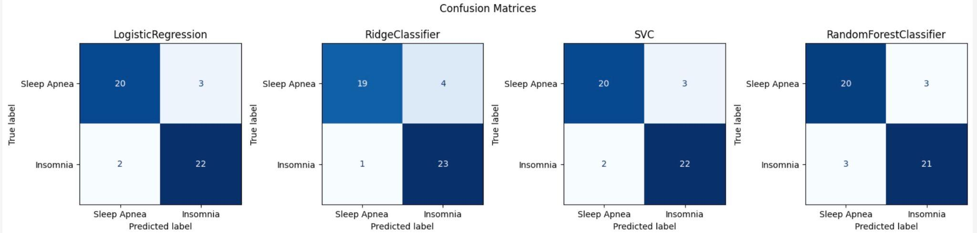

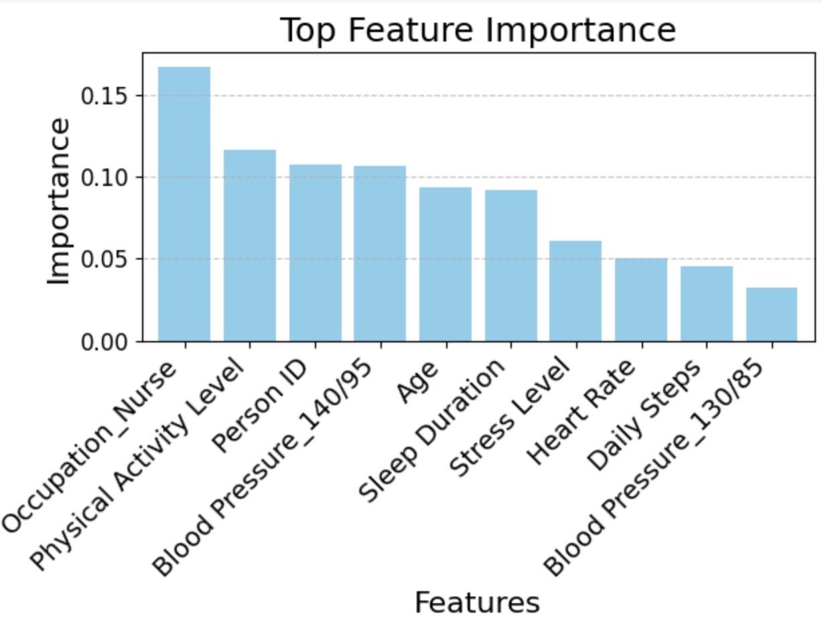

**APPENDIX C**

**PLAGIARISM REPORT**

